Portfolio Site Report

URL: <https://lollisjosh.github.io>

## Table of Contents

index.html

about.html

skills.html

projects.html

card_collection.html

ascii_draw.html

ascii.html

project_gal.html

GAL-Dev-2023-09-11.html

GAL-Dev-2023-09-18.html

GAL-Dev-2023-10-01.html

office.html

server_surfer.html

lunar.html

snake.html

blog.html

interests.html

music.html

guitar.html

composition.html

art.html

artwork.html

design.html

contact.html

### index.html

The homepage features a welcome message, profile picture with gradient border, and a brief introduction. It uses responsive design with different text sizes for desktop and mobile views, and loads dynamic content like the header, footer, and bio section.

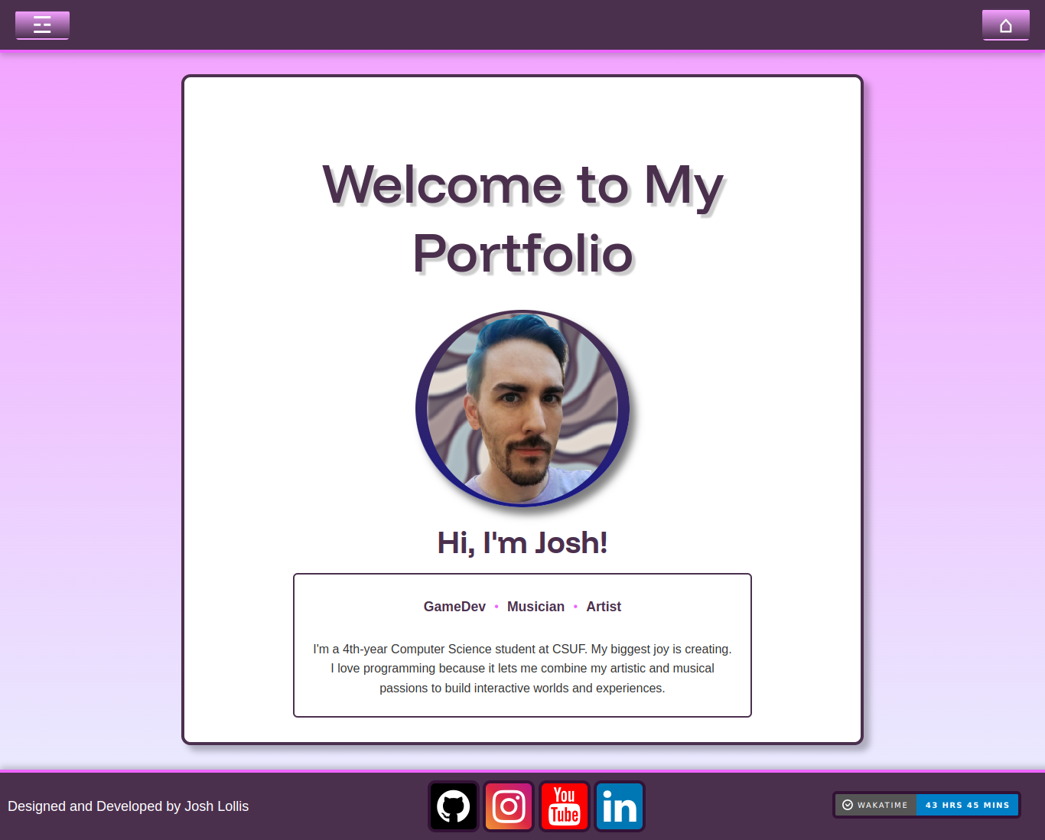

### about.html

The About page displays my personal information, including a profile picture with gradient border and a back button for easy navigation. Below the bio section, it features my Game Design Resume embedded as a PDF viewer with a download option. The page maintains the same styling as the homepage with the Funnel Display font and uses dynamic loading for the header, footer, and bio content.

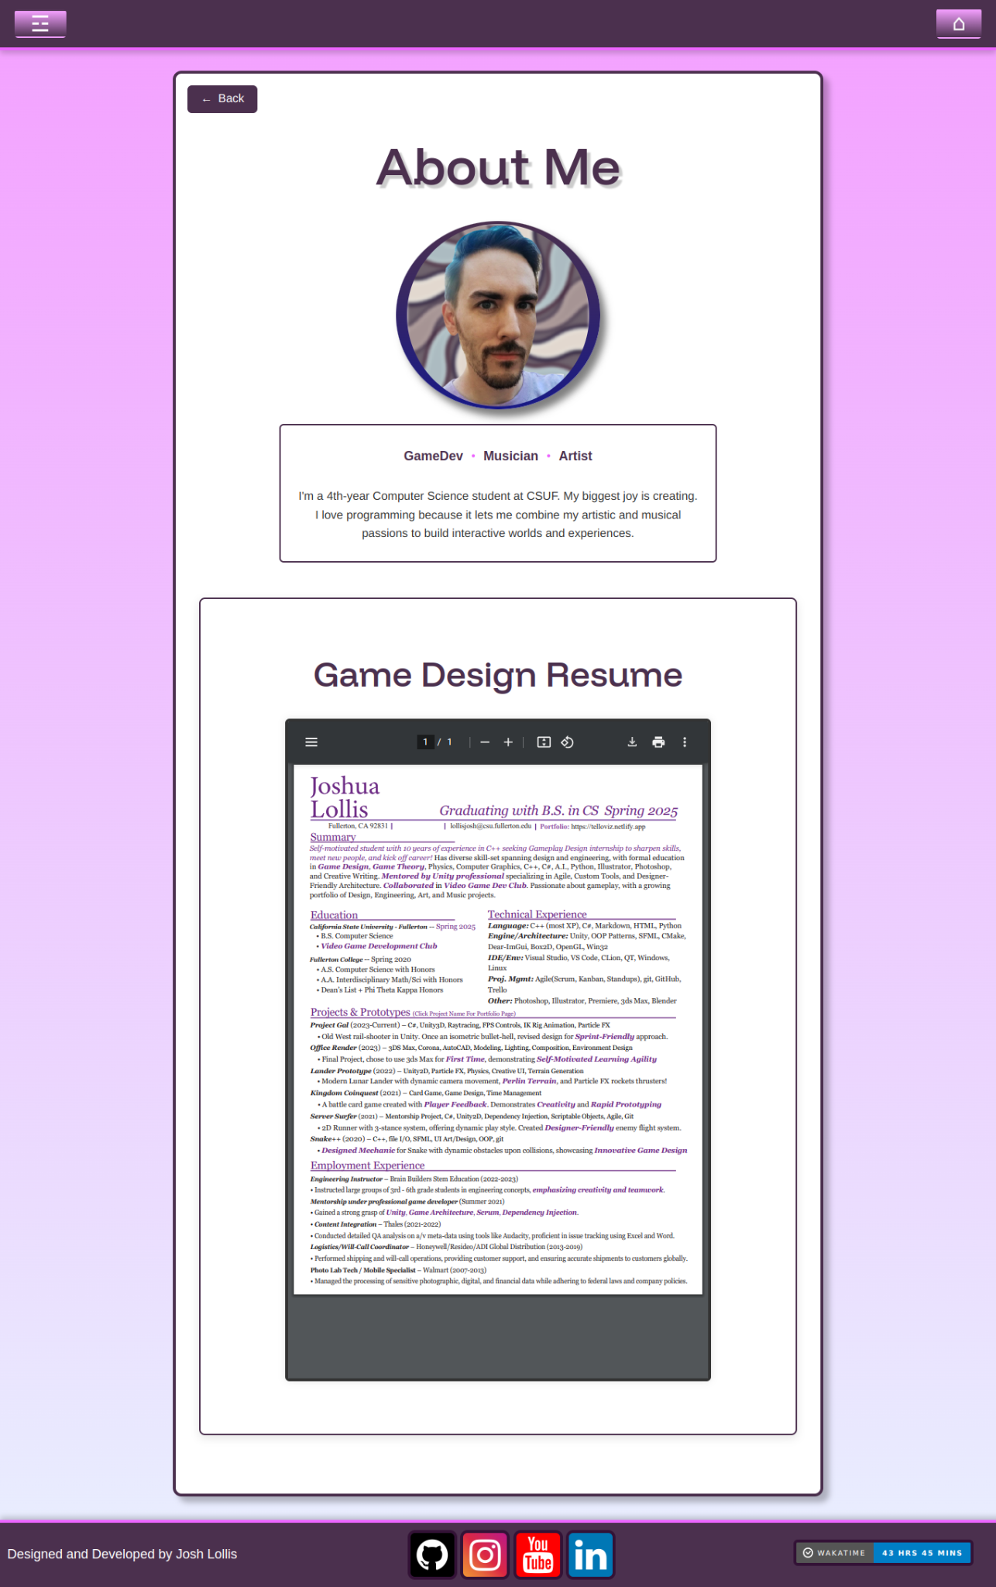

### skills.html

The Skills page displays my technical abilities through interactive pie charts showing programming language and editor usage statistics. It includes sections for Technical Proficiency, Soft Skills, and Technical Competencies. The page features a quick-navigation menu with icons at the top.

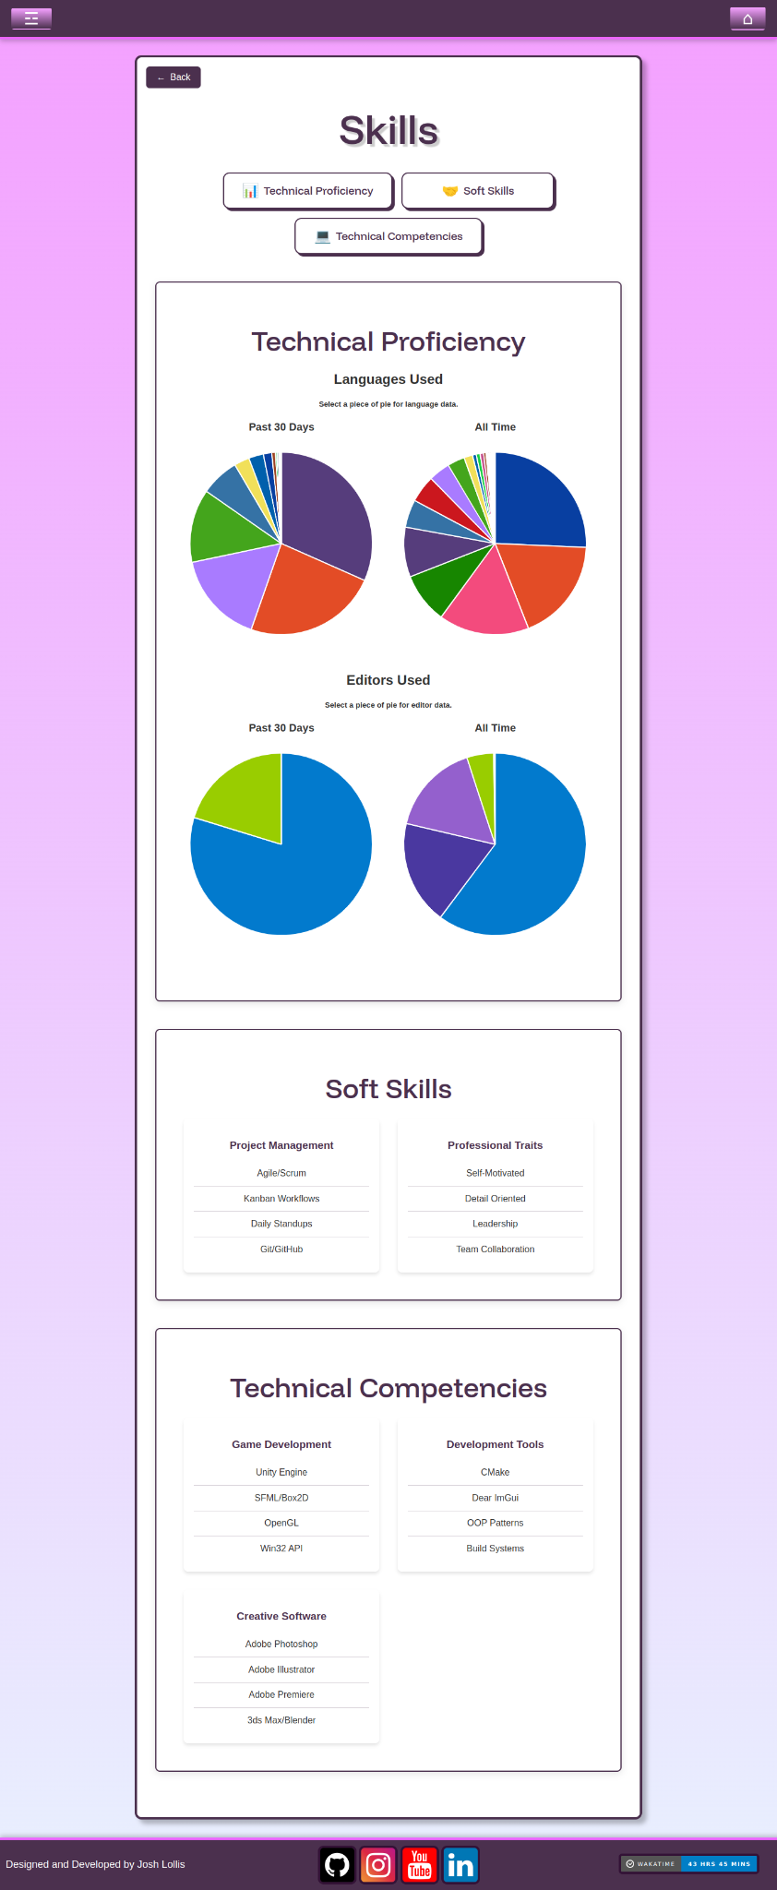

### projects.html

The Projects page displays a grid of my portfolio projects, each featuring an animated GIF preview and title. Projects include Card Collection, ASCII Draw, My Office, Project GAL, Server Surfer, Lunar Lander, and Snake. Each project card links to its detailed page, and the page includes a back button for navigation while maintaining the site's consistent styling.

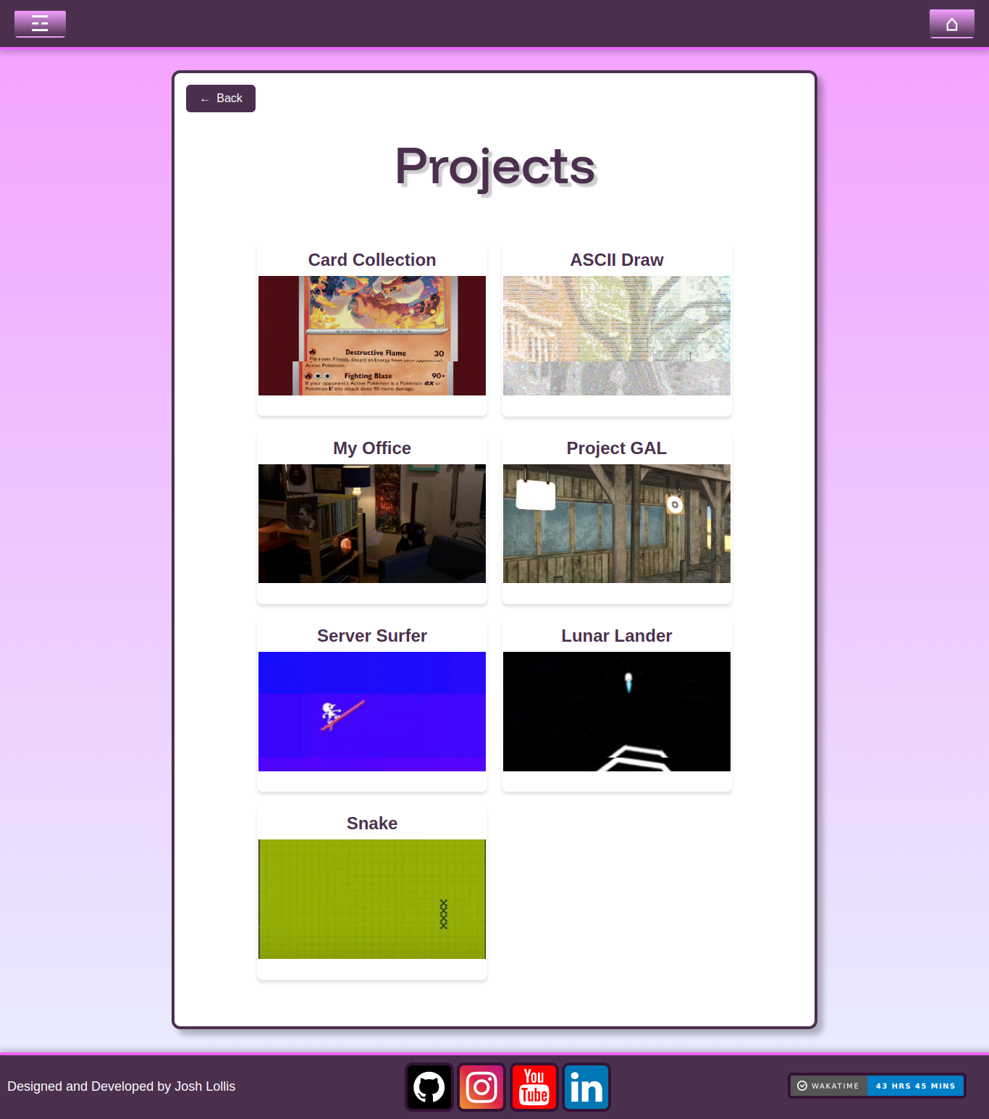

### card_collection.html

The Card Collection project page showcases a desktop application for collecting Pokémon cards. The page features a quick-navigation menu with sections for Overview, Implementation, Challenges, Outcomes, Videos, and Gallery. It includes detailed development progression through multiple versions, with screenshots showing the evolution from initial mockups to the final version featuring search functionality, 3D card views, and modular components. The page links to the GitHub repository and uses the site's consistent styling with the Funnel Display font.

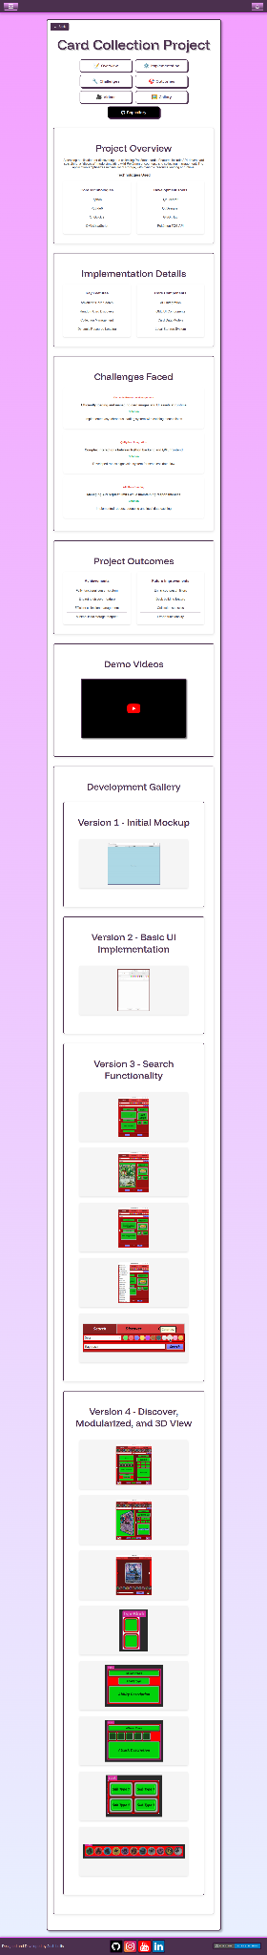

### ascii_draw.html

The ASCII Draw page showcases a project that converts PNG images into ASCII art. It includes sections for project overview, technical implementation, development challenges, and results, with links to both a live ASCII viewer demo and the GitHub repository.

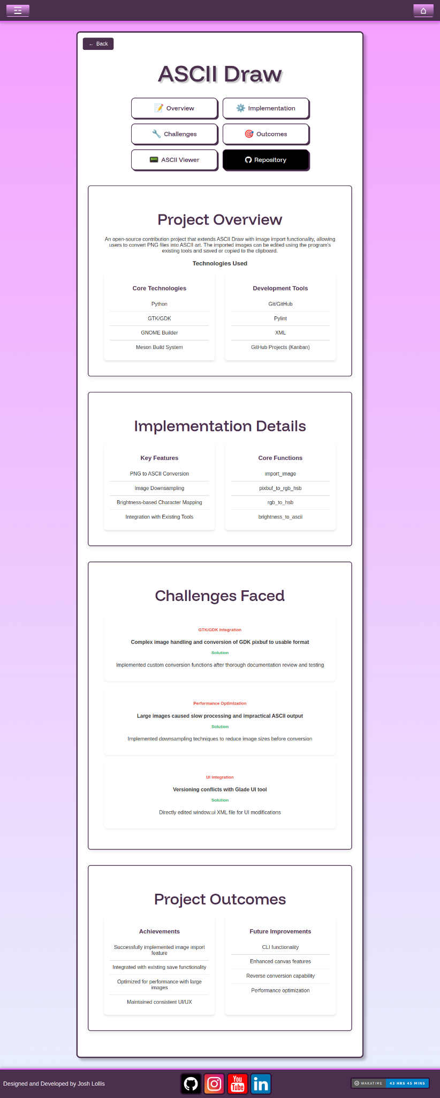

### ascii.html

The ASCII Art Gallery page provides an interactive viewer for converted ASCII art images. It features a dropdown menu to select different images and their downsampled versions, a zoom slider for size adjustment, and displays both the ASCII art and original image side by side. The page includes custom styling for the viewer's font, borders, and controls.

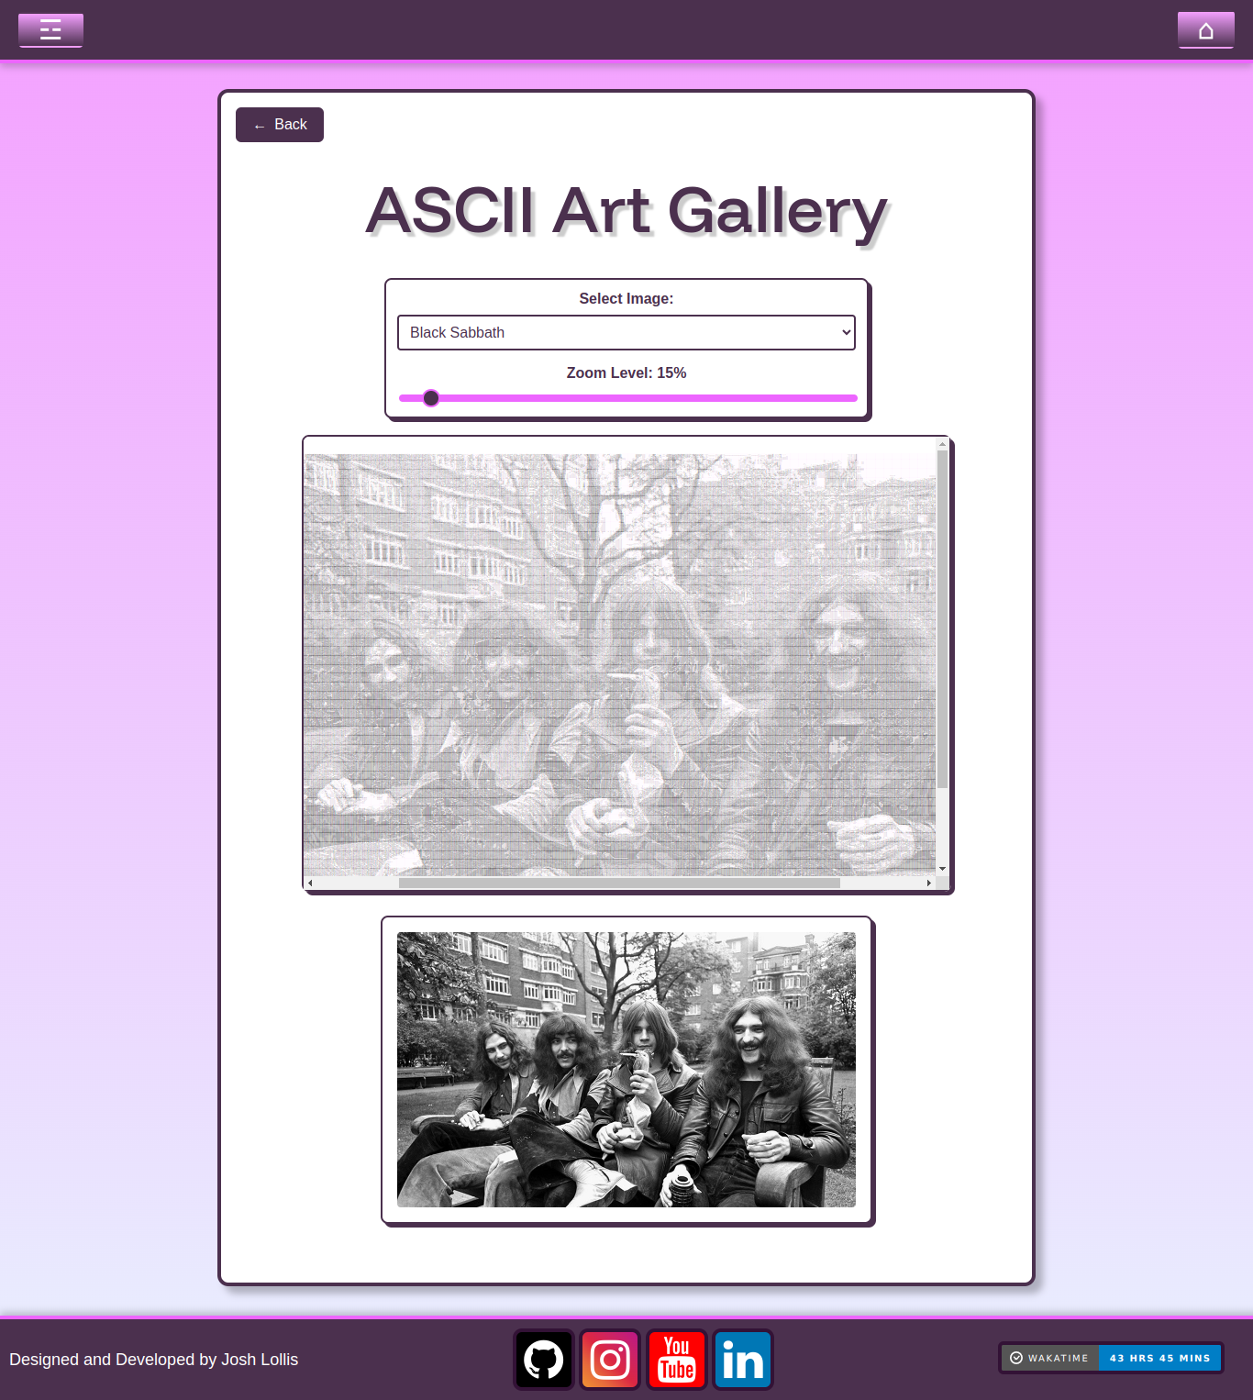

### project_gal.html

The Project GAL page showcases my Unity FPS game focused on target practice. Features include dynamic targets, custom physics, and particle effects. The page contains development logs, gameplay videos, a screenshot gallery, and links to the GitHub repository.

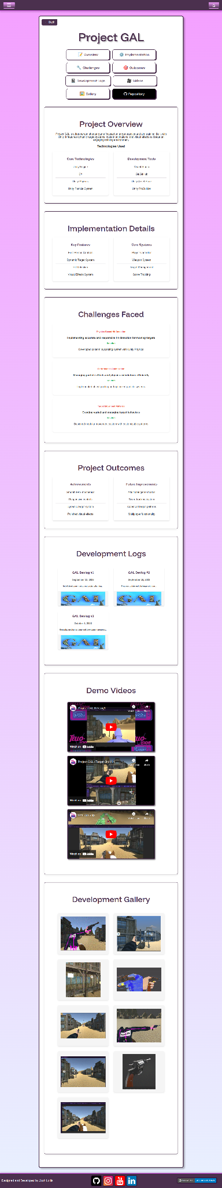

### GAL-Dev-2023-09-11.html

The GAL Development Log page documents my Unity FPS game's progress. It covers the project background, development approach using Unity patterns and prefabs, technical challenges faced with camera controls and performance, current shortcomings to address, and implemented features like the environment and player controller. The page includes a demonstration GIF of the target system and an embedded YouTube video showing gameplay progress.

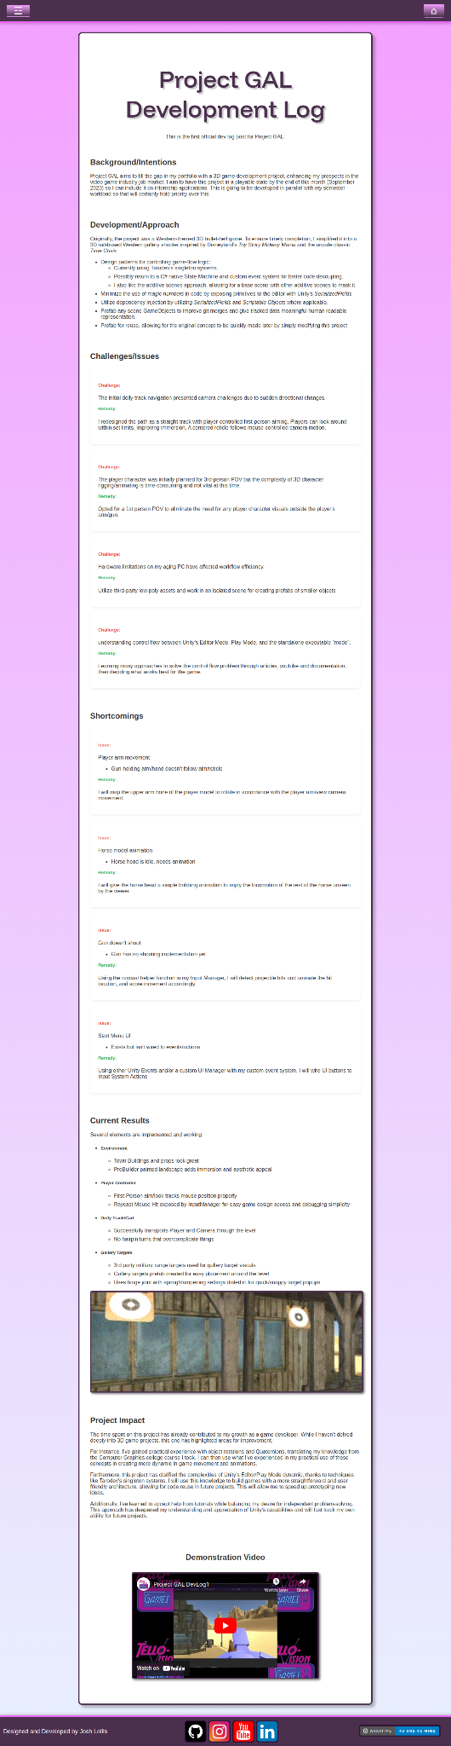

### GAL-Dev-2023-09-18.html

This devlog entry details my work on implementing first-person aiming controls in Project GAL. It covers the challenges faced with camera controls, player model clipping, and arm animations. The page includes GIFs demonstrating the mechanics, technical explanations of solutions implemented, and notes on player feedback and remaining issues to address.

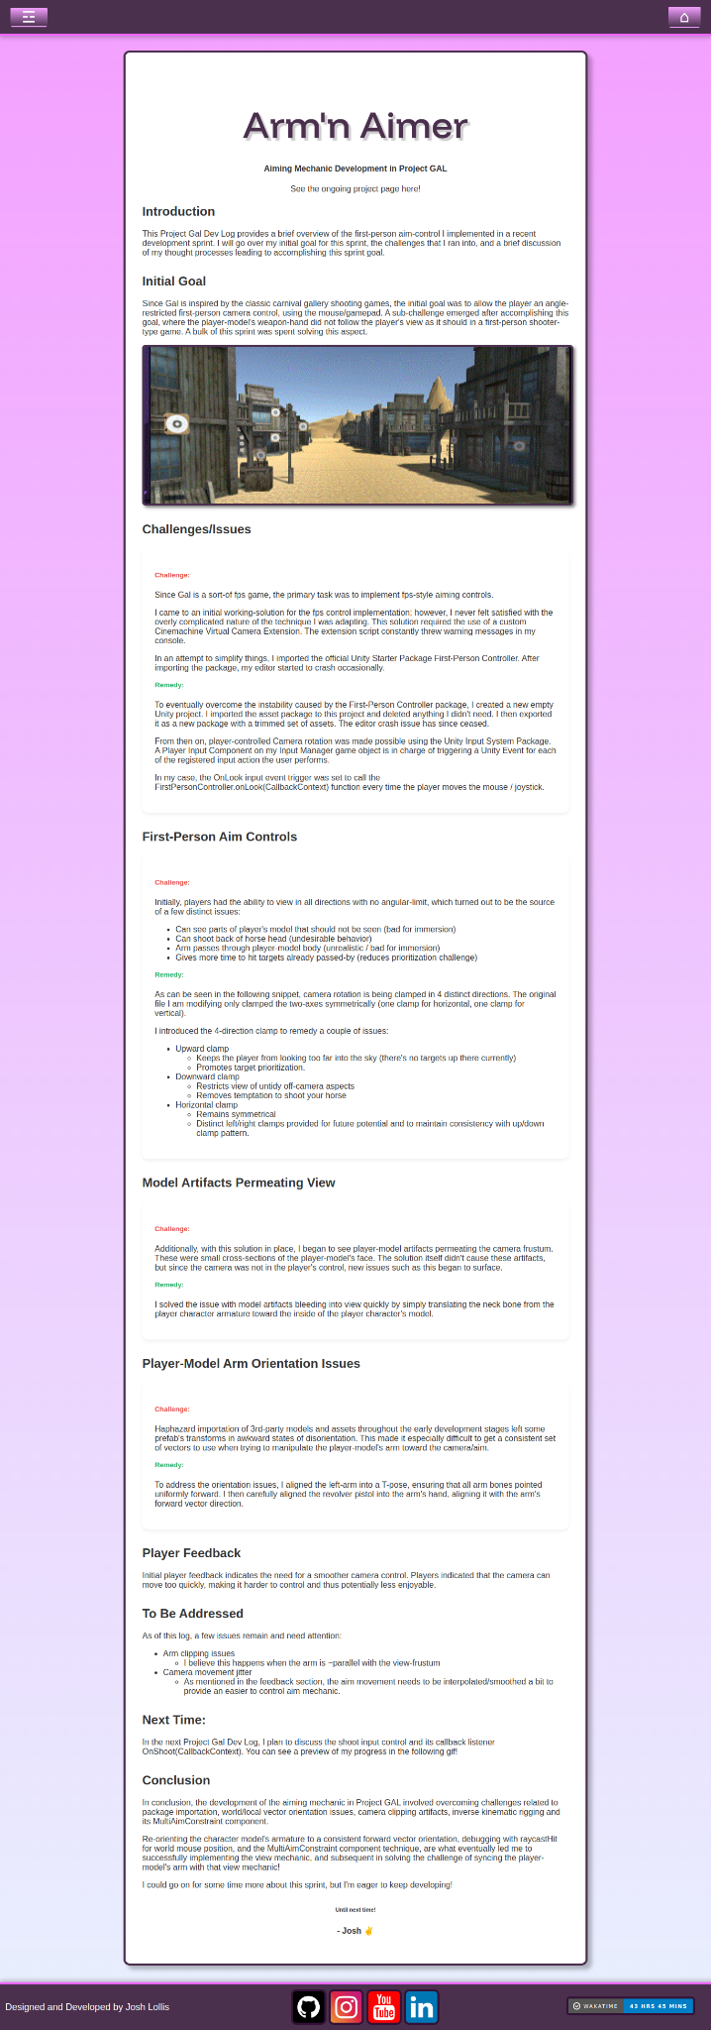

### GAL-Dev-2023-10-01.html

This devlog entry shows recent progress on Project GAL through two embedded YouTube videos - one demonstrating the new shooting mechanics and another showing extended gameplay footage. The page is a brief update with a note that a full write-up is coming soon.

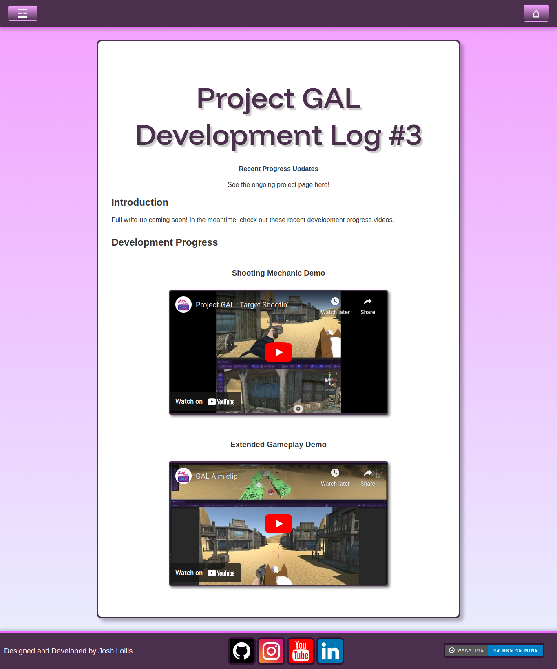

### office.html

The Office page shows my 3D visualization project - a detailed model of my home office built in 3ds Max and Corona, featuring advanced lighting and materials. The page includes technical details, development challenges, and a gallery of final renders. Over 100 hours went into creating this highly detailed environment.

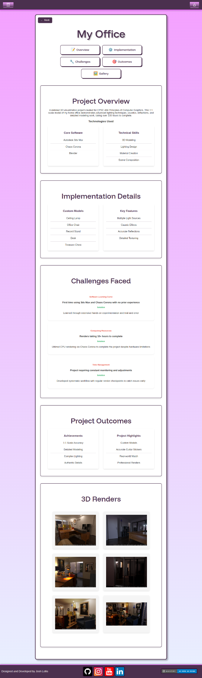

### server_surfer.html

The Server Surfer page showcases my 2D endless runner game built in Unity. It features a cyberpunk surfer theme, with mechanics including 3-stance gameplay, dynamic enemy behaviors, and custom flight patterns. The page includes a brief overview and multiple development videos showing the game's evolution from initial concept to current state.

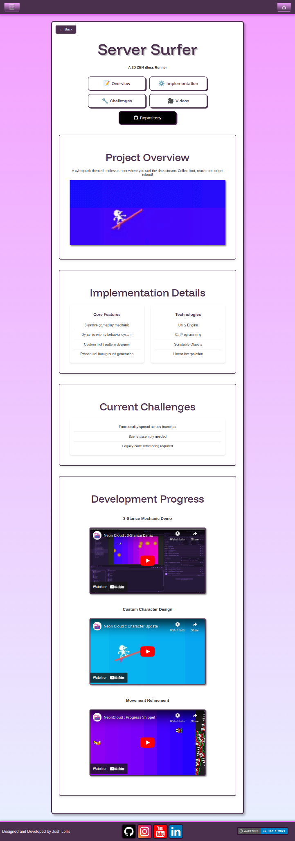

### lunar.html

The Lunar Lander page is currently a placeholder for my Lunar Lander project with just a title and "Coming Soon..." message. It maintains the site's consistent styling with the Funnel Display font and includes the standard header/footer placeholders and back navigation button.

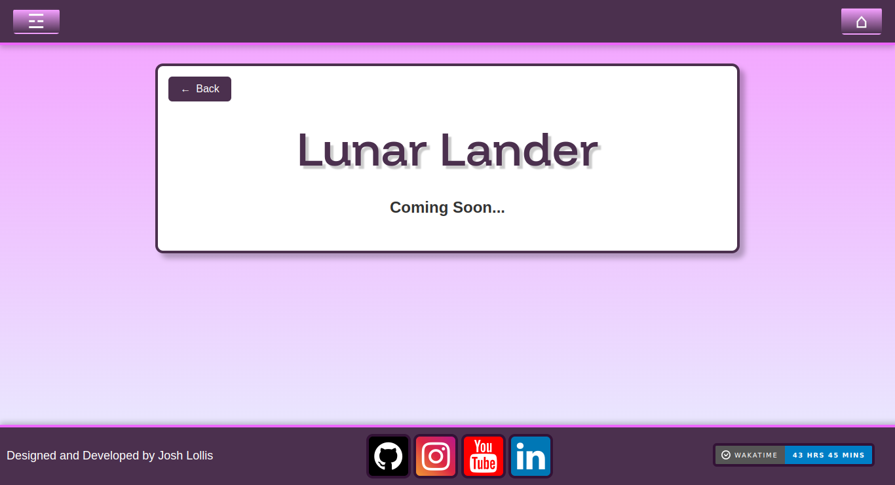

### snake.html

The Snake page is currently a placeholder showing only the project title and a "Coming Soon..." message. It follows the site's standard template with the Funnel Display font, dynamic header/footer loading, and back navigation button.

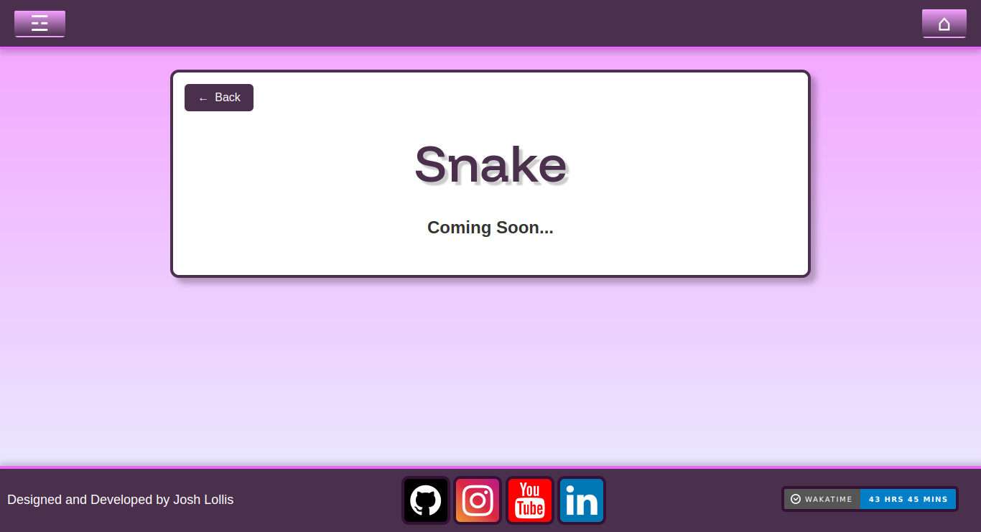

### blog.html

The Blog page shows Project GAL development logs (Sep-Oct 2023) with titles, dates, and preview GIFs in a grid layout. Has placeholders for future blog categories while using site's standard styling and navigation.

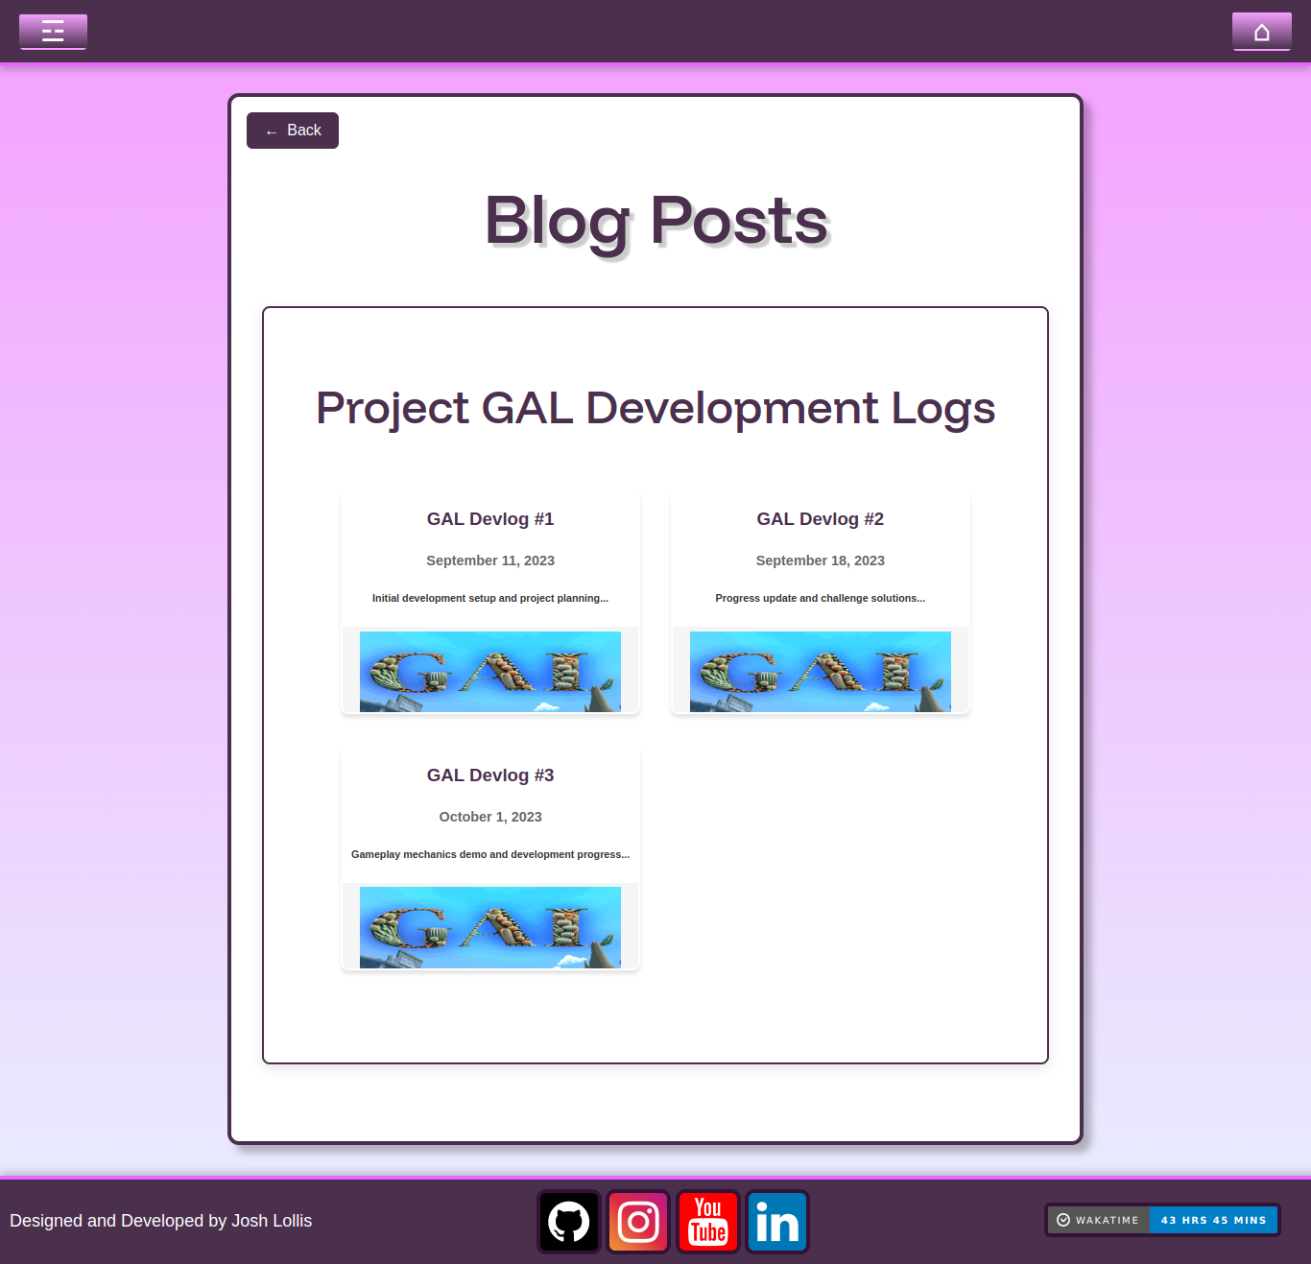

### interests.html

The Interests page shows my hobbies outside of programming - Music & Production and Art & Design

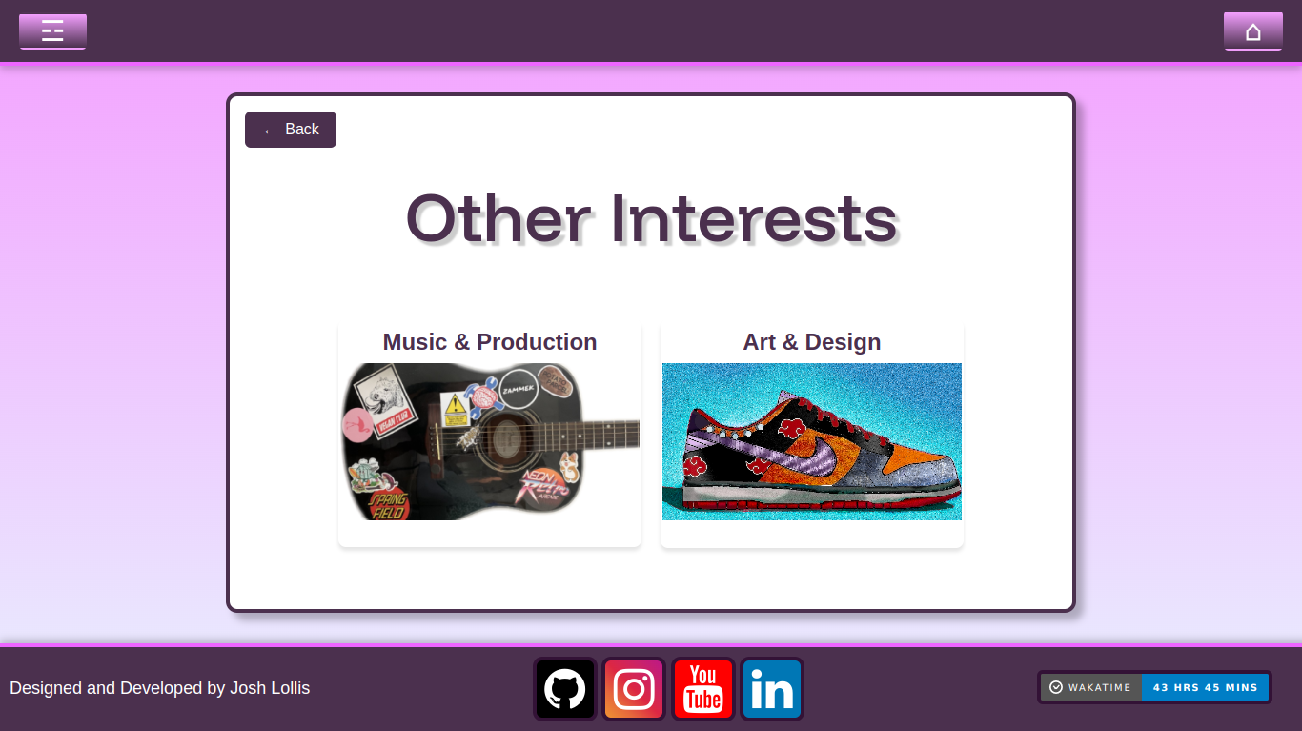

### music.html

The Music & Production page splits my musical interests into two categories - Guitar & Bass and Composition - each with its own preview image and link. The page maintains the site's navigation and styling.

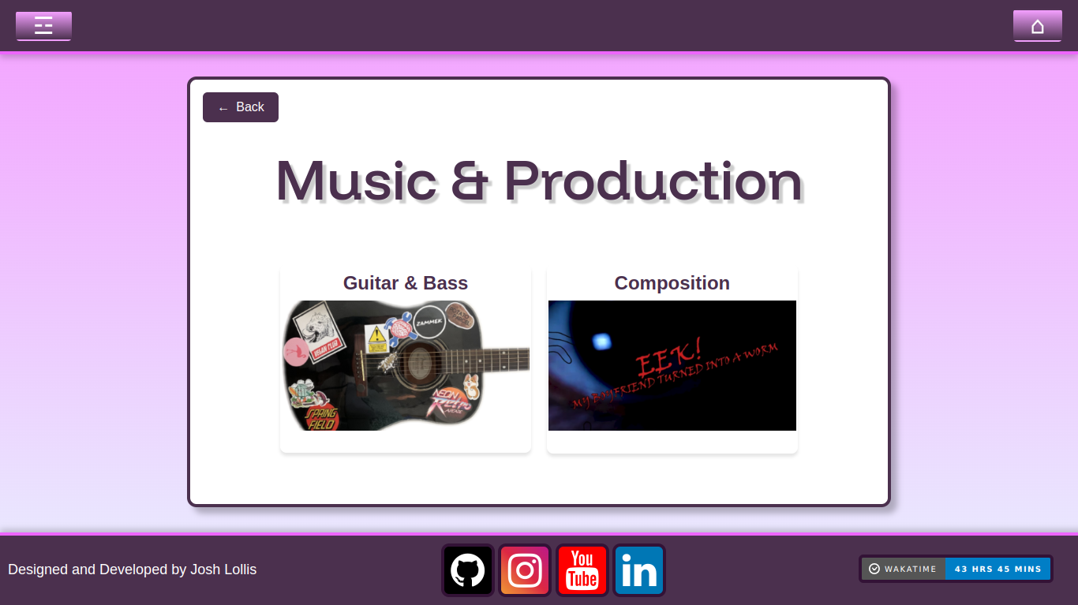

### guitar.html

This page features sections for my Guitar and Bass Guitar performance videos. It is in the same style as the project pages.

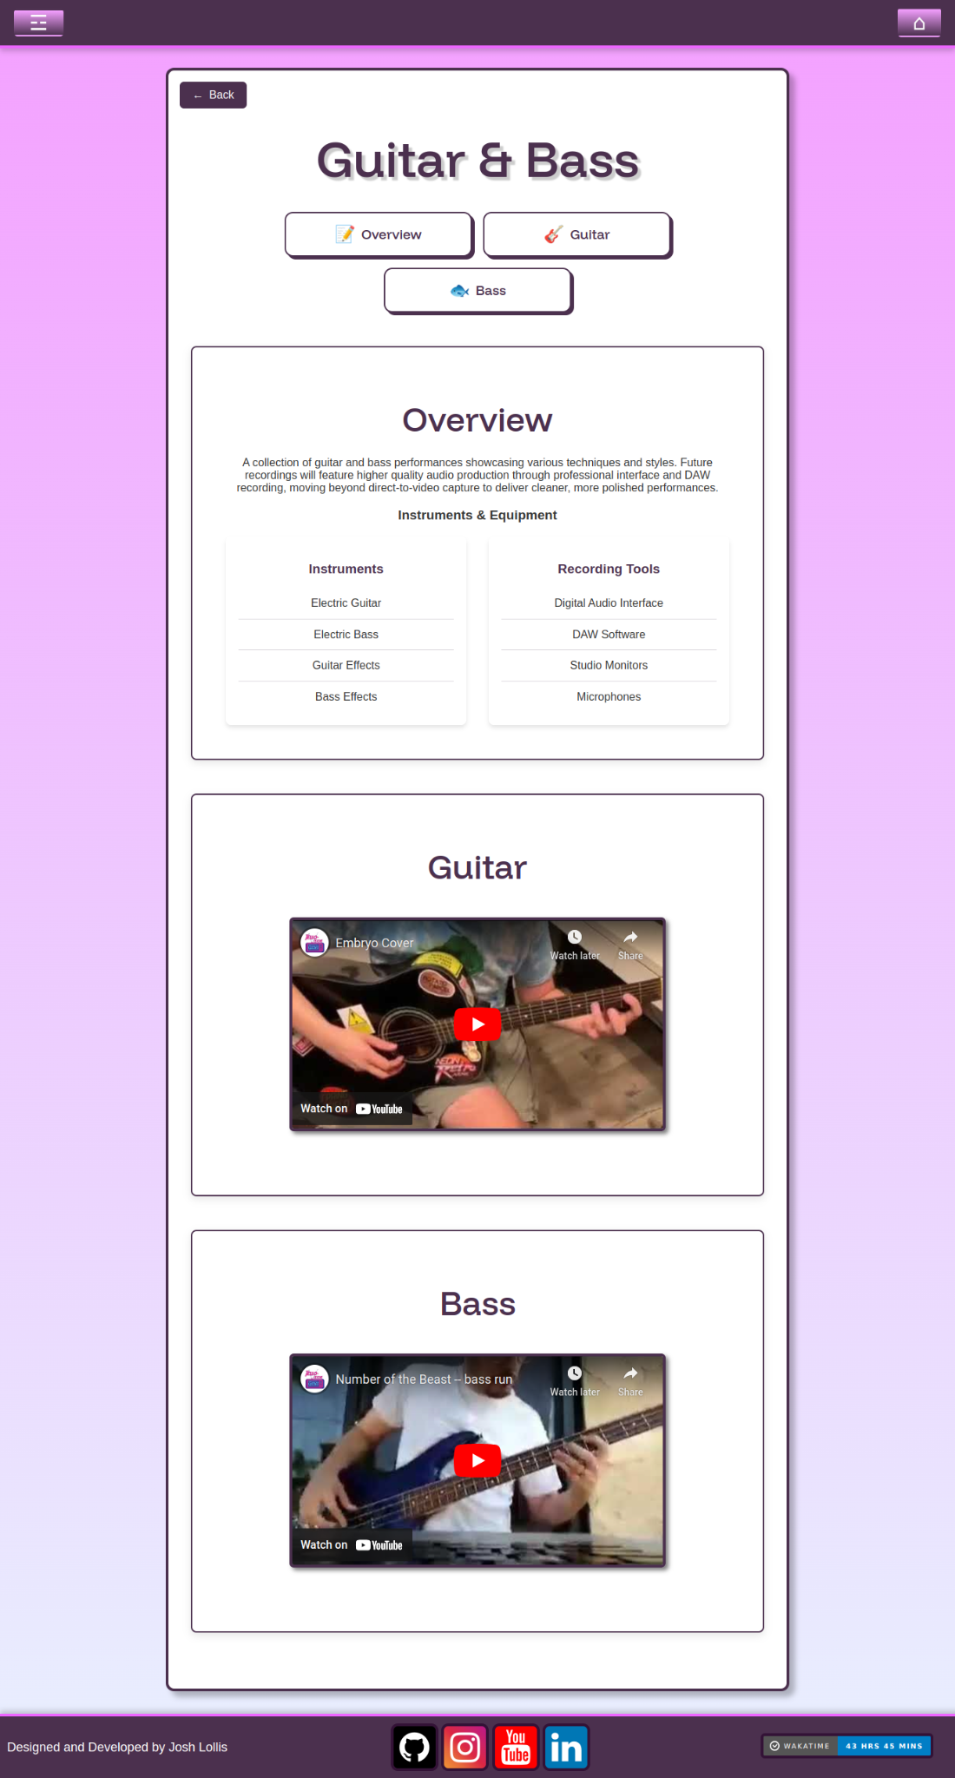

### composition.html

The Composition page highlights my original music work, including student film soundtracks and personal pieces. It features several musical compositions with embedded YouTube players and lists the tools and techniques I use for creating music. Uses the same clean layout and navigation as other pages.

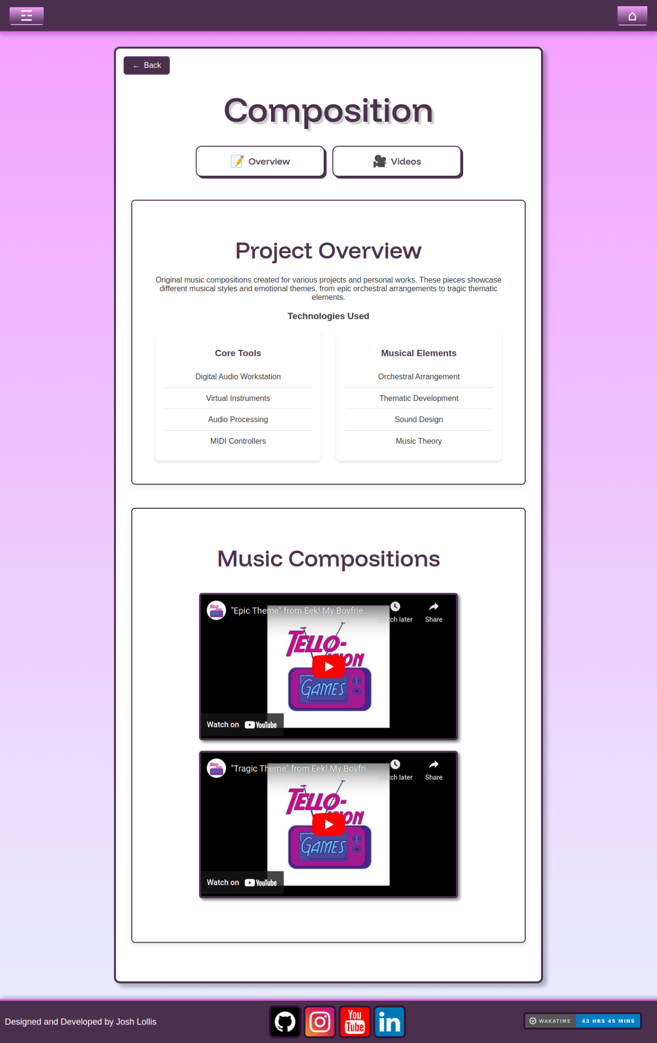

### art.html

The Art & Design page splits my visual work into two categories - Artwork and Design - each with a preview image and link to a dedicated page.

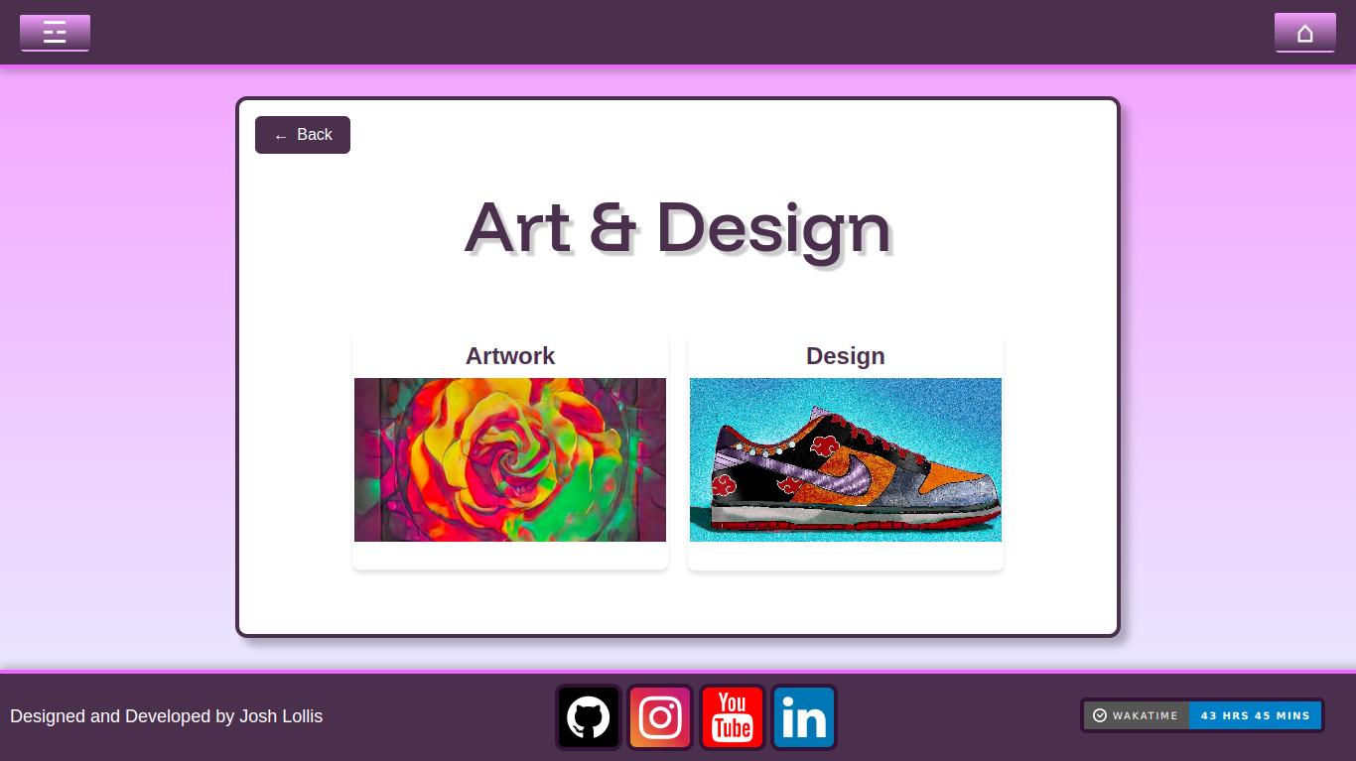

### artwork.html

The Artwork page features a carousel gallery of my digital art pieces, with navigation buttons to browse through images. Each image can be viewed in full resolution, while maintaining the site's consistent styling and navigation elements.

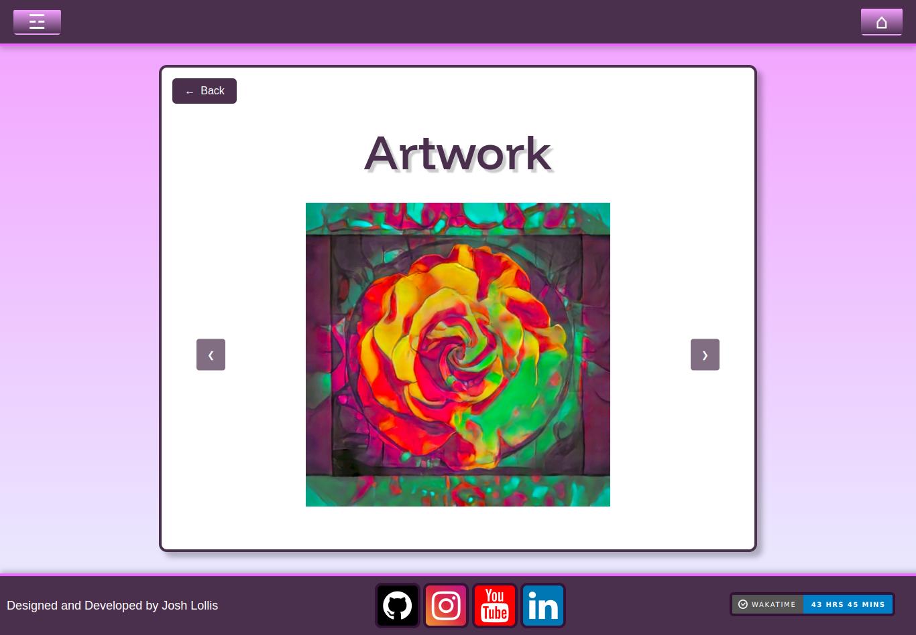

### design.html

The Design page displays a carousel gallery showcasing my design work, starting with shoe designs. It includes navigation arrows to browse through images and allows for full resolution viewing, using the same carousel system and styling as the Artwork page.

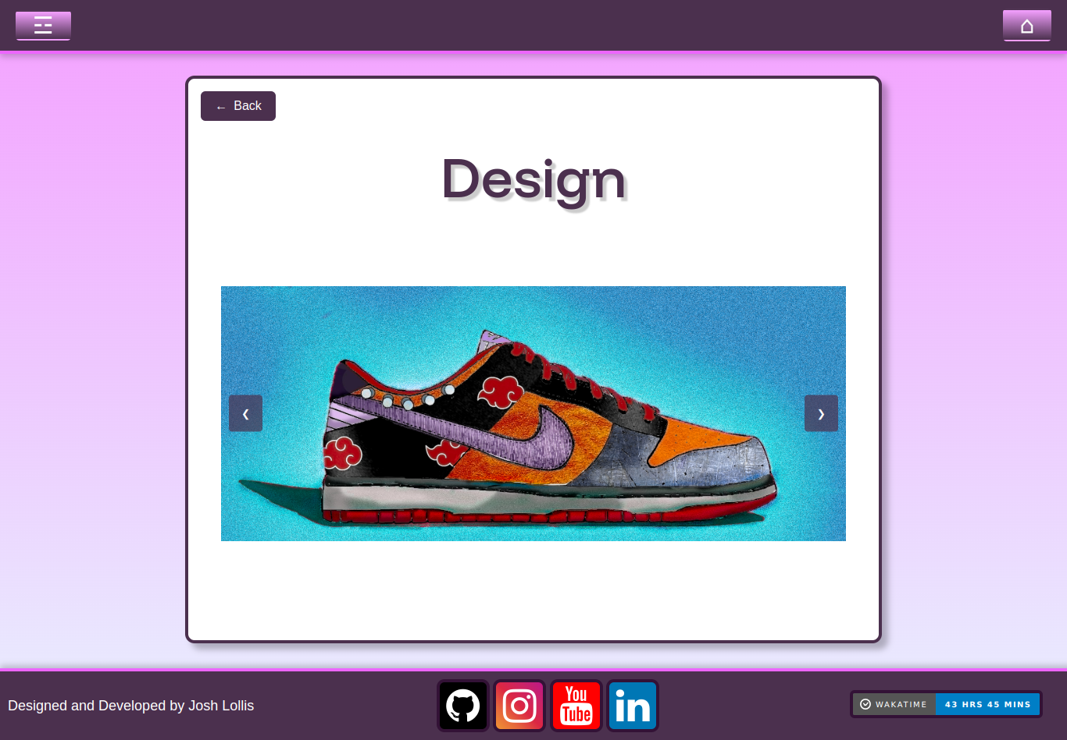

### contact.html

The Contact page features a profile picture and a simple contact form powered by Formspree. The form includes fields for name, email, and message, with a submit button. Like other pages, it uses the site's standard navigation and Funnel Display font styling.

